CEO/Clinical Servicers Manager : Lynette Foskett
Year of Service Celebrations

Lucy – 20 years

Diane – 30 years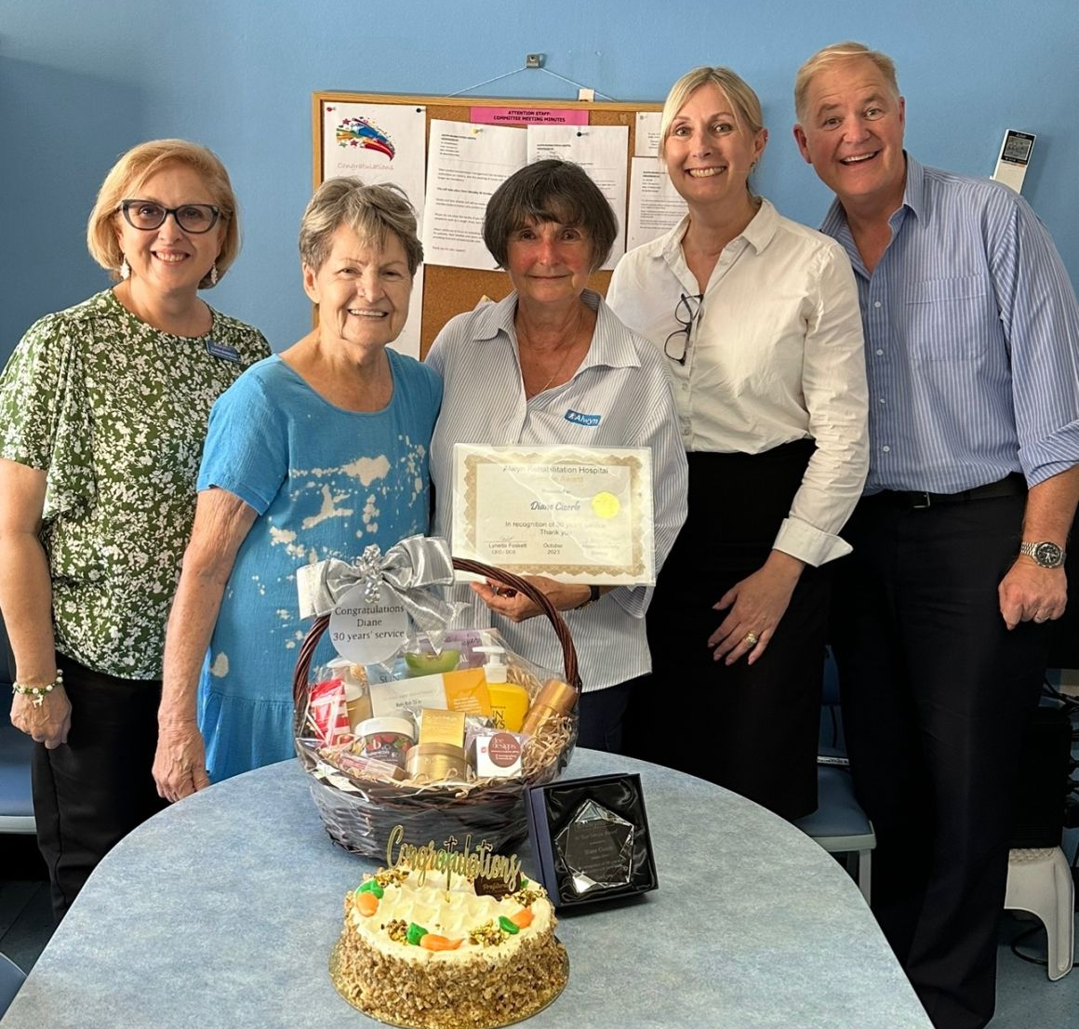

Christmas 2023

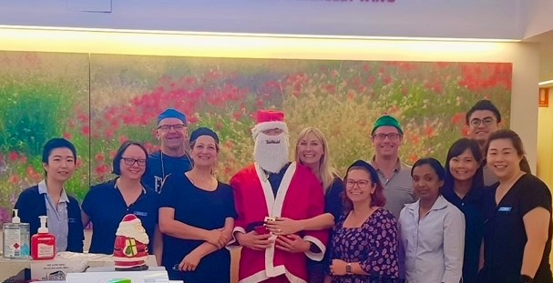

ARH Safety & Quality News
Alwyn Rehabilitation Hospital | December 2023 | www.alwyn.com.au

Consumer Representative: Judy Dekker

HAND HYGIENE AUDIT THREE

Correct Moments 114 Total Moments 120
Alwyn Rehab 95% National 86.7%

Before Touching a patient – 100%
Before Procedure 100%
After a procedure or Body Fluid Exposure Risk 100%
After touching a patient 96%
After touching a patient’s surroundings 90%

July – Sept 2023 CLINICAL INDICATOR RESULTS

HA – Hospital-acquired OBD= Occupied Bed Days BM - Benchmarking

INDICATORS | Alwyn | BM Hospitals
HA Infection Rates | 0.03 | 0.42
HA Pressure Injury | 0.0 | 1.27
Patient Fall | 0.0 | 0.32
Harm from Patient Falls | 0.06 | 0.07
Transfer to acute facility | 0.0 | 0.01

AUDIT RESULTS.

Environmental Cleaning Audit 82.5% overall cleanliness

Clinical Process Review 100% Benchmarking

May the holiday season be a reflection of the joy and gratitude we hold for your extraordinary contributions to our collective well-being.

